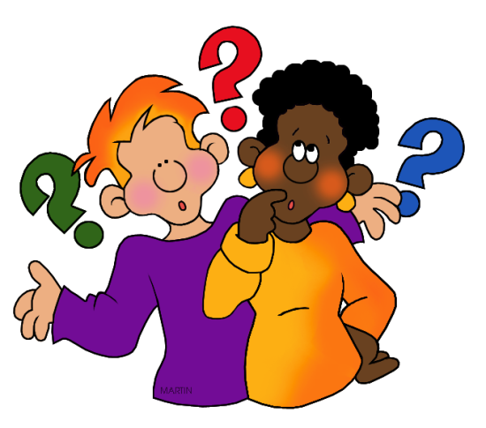
1. A Testable Question needs 2 parts:
(1) A _____________ variable
(2) An _____________ variable

2. Is the following question testable?
What makes plants grow best?

3. IF your answer is no, rewrite it in a testable form

