What do Good Readers do?

- Read different genres of books
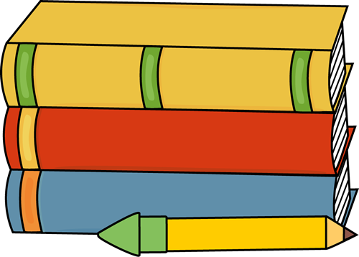
- Choose good fit books
- (Rule of 5, interesting)
- Read the teaser on the back of the book
- Know the author and illustrator of the book
- Make predictions about what will happen next
- Read with pacing and expression
- Think about what they are reading (self-monitoring)
- Make connections to what they are reading
- (text to text, text to self, text to world, text to media)
- Share about what they read with others (without spoiling!)
- Make pictures in their mind of what they are reading (visualize)
- Ask questions about what they are reading
- Read between the lines (infer)
- Take away main ideas and themes from what they have read
