THE THIRD-FLOOR BEDROOM
____________________
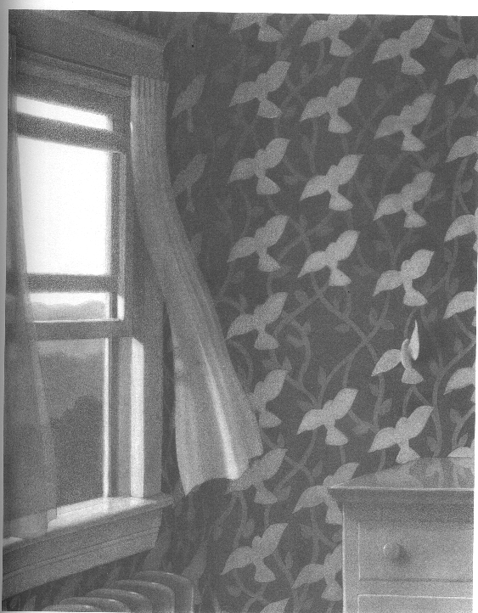
It all began when someone left the window open.

Archie Smith, Boy Wonder
_________________________
A tiny voice asked, "Is he the one?"
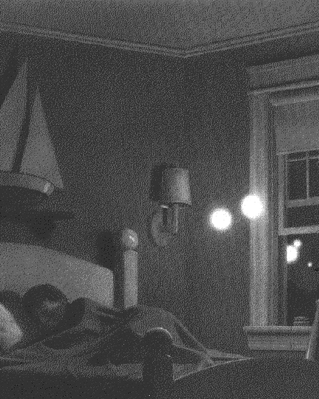
UNDER THE RUG
_________________
Two weeks passed and it happened again.
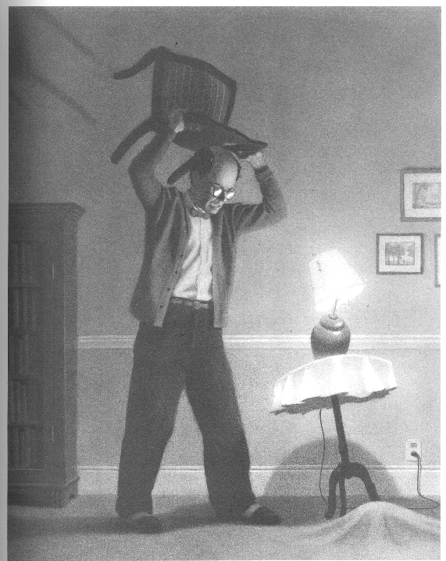
A STRANGE DAY IN JULY
____________________
He threw with all his might, but the
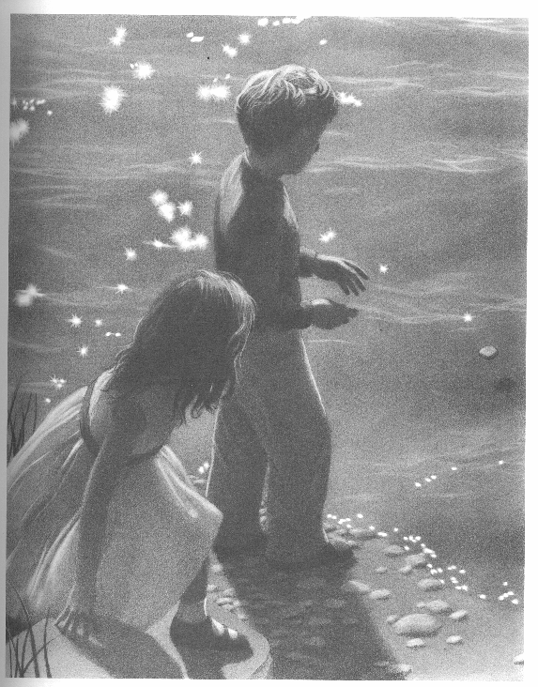
third stone came skipping back.

MISSING IN VENICE
_________________
Even with her mighty engines in reverse,
the ocean liner was pulled further and
further into the canal.
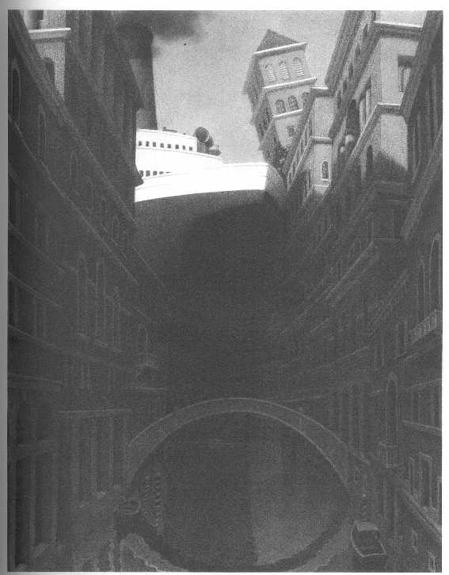
ANOTHER PLACE, ANOTHER TIME
_____________________________
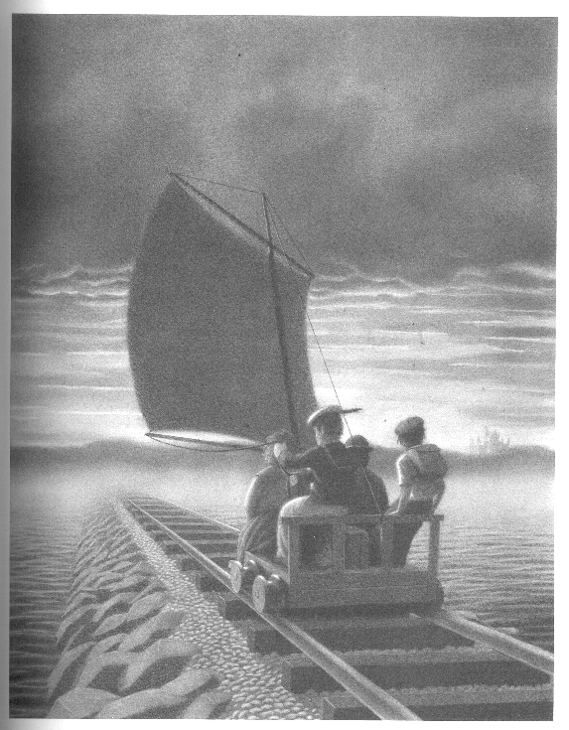
If there was an answer, he'd find it there.

UNINVITED GUESTS
___________________
His heart was pounding.
He was sure he had seen the doorknob turn.
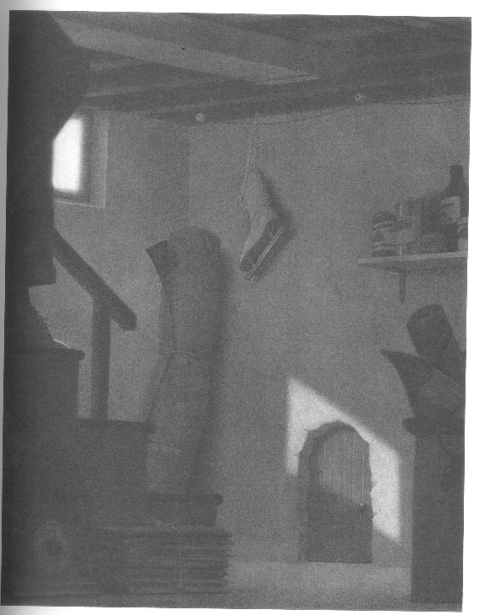
THE HARP
__________
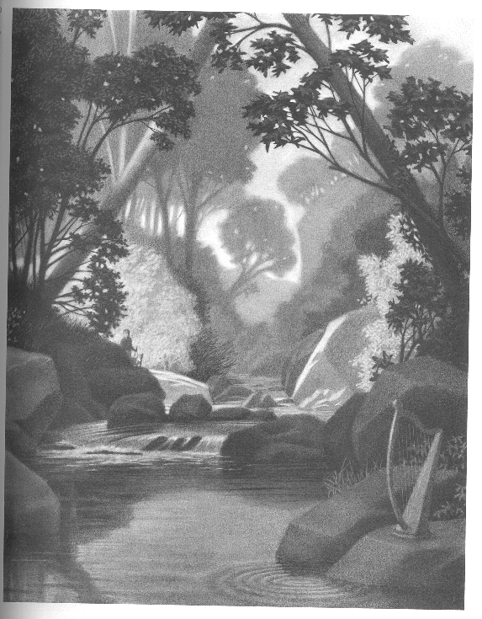
So it's true he thought, it's really true.

MR. LINDEN'S LIBRARY
___________________
He had warned her about the book.
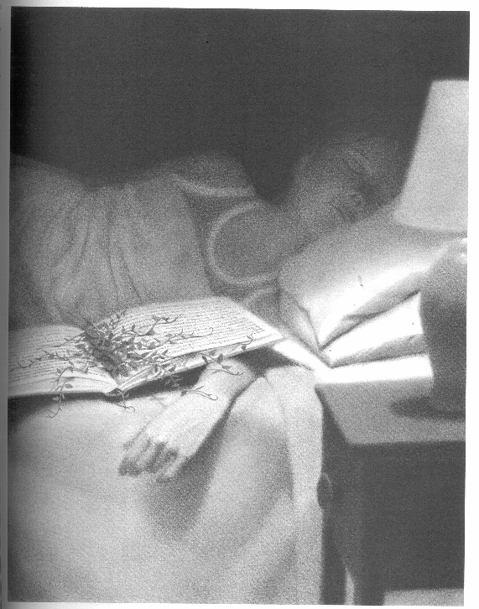
Now it was too late.

THE SEVEN CHAIRS
_________________
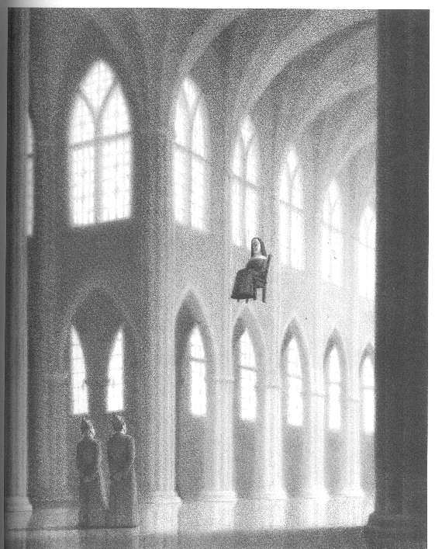
The fifth one ended up in France.

JUST DESERT
______________
She lowered the knife and
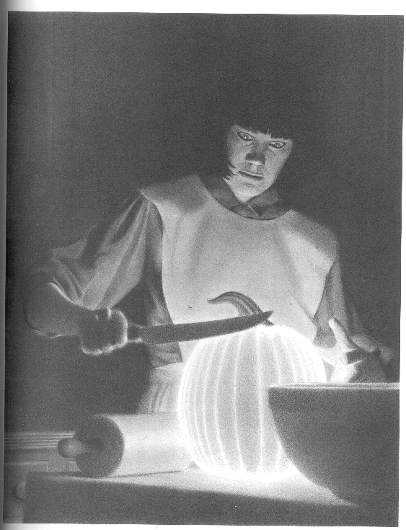
it grew even brighter.

CAPTAIN TORY
_______________
He swung his lantern
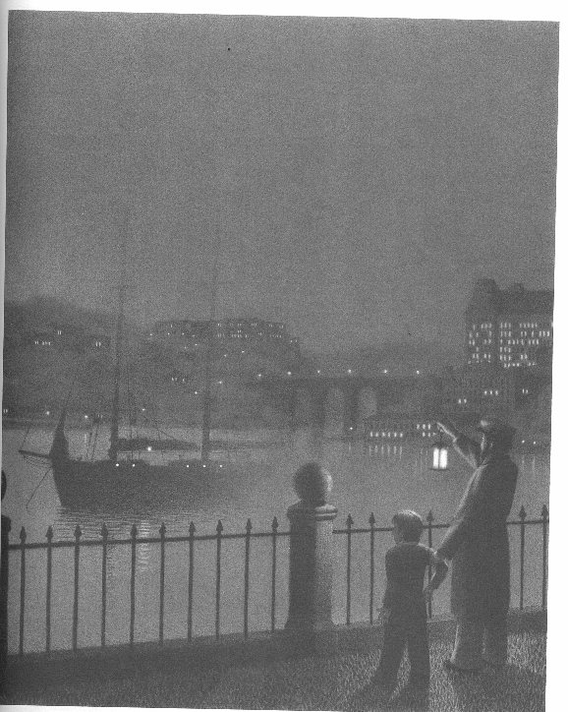
three times and slowly the schooner appeared.

OSCAR AND ALPHONSE
_____________________
She knew it was time to send them back.
The caterpillars softly wiggled in her hand,
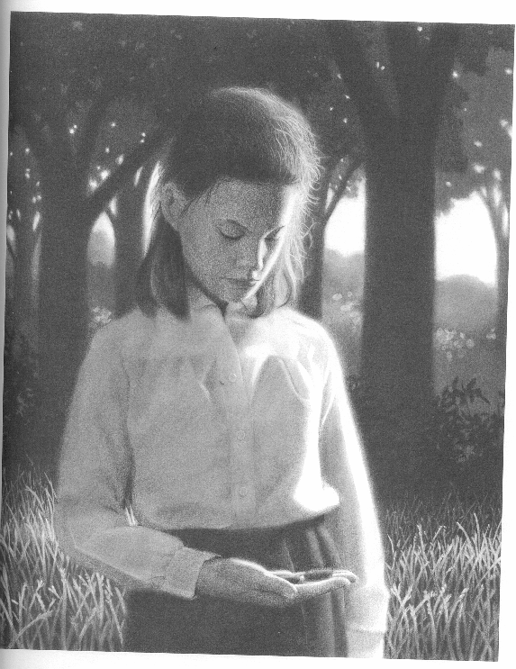
spelling out "goodbye".

THE HOUSE ON MAPLE STREET
____________________
It was a perfect lift-off.
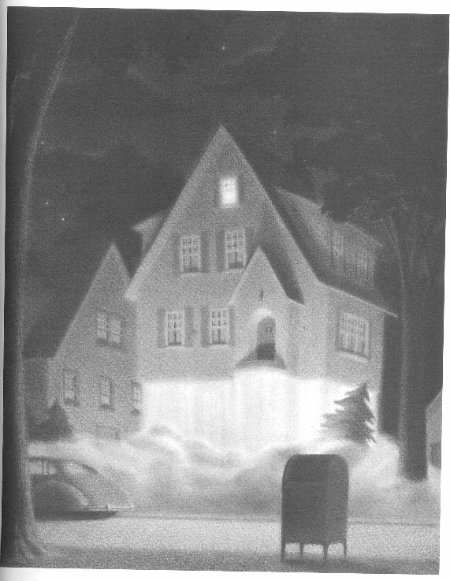
Write 3 observations about the picture:
1.
2.
3.

Write 1 inference about the picture:
1.
An encounter between a children's book editor named Peter Wenders and an author and illustrator named Harris Burdick, who says he has 14 stories that he has written; he has brought one picture from each story with a caption. He leaves with a promise to deliver the complete manuscripts if the editor chooses to buy the books. The next day, Burdick didn't show up. Burdick never returned to Wenders' office. Over the years, Wenders tried to find out who Harris Burdick was, but he never found out. Burdick was never seen again, and the samples are all that remain of his supposed books. Readers are challenged to imagine their own stories based on the images for the books.
In 1984, Chris Van Allsburg visited Wenders' office, and Wenders showed him Burdick's drawings. Van Allsburg decided that maybe if he published the drawings, they may find out who Harris Burdick was.
Both Wenders and Van Allsburg were sure that someone would come with information about Burdick. Then, in 1993, a dealer in antique books, told them that he had purchased an entire library that had previously belonged to a recently deceased woman, including an antique mirror with portraits of characters from Through the Looking-Glass. The mirror fell from the wall and cracked open. Neatly concealed between the wooden frame and the mirror was an image identical to Burdick's other works; its caption identified it being from the Burdick story "Missing in Venice".^{[citation needed]}
As stated on the Burdick website, Peter Wenders died in 2000 at the age of 91.

