- Does changing the height of the ramp affect the speed of the car going down the ramp?
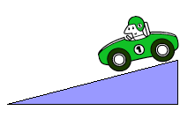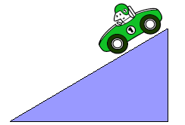

- Does changing the amount of light affect the growth rate of plants?
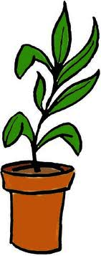
- Does the temperature of water affect the time it takes a sugar cube to dissolve?

