Progression of Subtraction Outcomes by Julie Roy

Knowledge | (Outcome) | Strategy
1. One less  (3-1, 5-1…up to 10-1) | KN1 | Counting sequence backwards (10,9,8,7,6,5,4,3,2..)  Finding the difference between 2 numbers that are 1 apart. i.e. 6 and 7…
2.Partners to 5  (1+ ___=5 , 2+ _____=5… I have 2 and I want 5 how many more? | KN2 | Using 5 frames to count.
3. Two less  (2 - 2, 4 - 2…up to 10-2) | 1N1 and 1N8 | From knowing one less.  (This is fairly difficult, takes time to practie and need to be logical about it.)
4.Comparing numbers less than 10  4 and 6, which is more, how many more? | KN5 and  1N5 | Using linking cube towers and comparing height and counting the difference. Start with a difference of 1, 2, 3, 4, 5, …
5. Partners to 10  (1+ ____=10, 4+____=10) | 1N10  2N10  3N10 | Ten frame, visualizing fingers, linking cube trains…  This is the most important concept for subtraction.
5A. Partners to the next multiple of 10  23 + ____ = 30 |  | Think of partners to 10
5B. Partners to 20  6 + ___ = 20 |  | Number line
6. Looking at the difference between 10 and a teen number  (16-10, 13-10…) | 1N9  2N10  3N10 | Using double ten frames, two sets of hands, linking cube trains are best for this so is money (pennies and dimes)
7. Looking at the difference between 9 and a teen number  (16-9, 13-9…) | 1N9  2N10  3N10 | From knowing subtracting 10.  9  10  16  1  6  Knowing that 16 and 10 have a difference of 6 helps you understand why the diffeence between 9 and 16 will be 7. It is important not to have rules but rather thinking models like the number line. When rules are fogotten, models remain.
8. Looking at the difference between 8 and a teen number  ( 14-8, 12-8, 14-8…) | 1N9  2N10  3N10 | Thinking about what happens when you subtract 10 from a number. For example16 – 8 = 8  8  10  16  2  6
9. Looking at the difference between 7 and a teen number  ( 16-7, 13-7, 12-7, 11-7) | 1N9  2N10  3N10 | Thinking about what happens when you subtract 10 from a number. For example 12 - 7=5  7  10  15  3  2
10. Looking at the difference between numbers that have the same digit in the ones place  (17-7, 25 - 5, 34 - 4..) | 1N9  2N10  3N10 | Thinking about what you know when the ones digits are the same in both numbers. Finding the difference between 7 and 17 , from 8 and 18, 6 and 16 and extrapolating from there what happens. ( i.e. the difference is ten or a multiple of 10 since the ones digit are the same.
11. Looking at the difference between numbers that have almost the same digit in the ones place, i.e. one apart.  (16-7, 24 - 5, 35 - 4..) | 1N9  2N10  3N10 | From knowing adding 10.  For example, if 16 -6 is ten, well 16 – 7 is the same as 16 -6 -1 which must be the same as  10 -1 = 9
12. Three less | 1N9  2N10  3N10 | For example, if you have 15 – 3, it is generally simpler to to think of 3 less than 5. Look at two less than 5 and then compare it to 2 less than 15 and discuss similarity differences. Find the pattern.
13. Four less, Five less and Six less | 1N9  2N10  3N10 | For these numbers, often it is easier to break them in parts rather than see them as whole. For example, 12-4 can be looked at as 2 less than 12 which is ten and then 2 less than 10. If students are more comfortable looking at them as 4 + ____=12 and know that 4 + 6 is ten and two more for 8 that is also fine.
13B. Subtraction of the facts
14. Looking at the difference between 10 and any number. | 2N9  3N1 | When representing numbers with number cubes, you can compare numbers with one ten. For example, 10 and 14. 10 and 27, 10 and 58 and look at the difference of many numbers and ask the students to try to figure out what happens and to “guess” a new set of numbers.
15. Looking at the difference between multiples of ten (20,30,40,50,60…) and other multiples of ten both less than one hundred. | 2N9  3N7 | For this one, it is a good idea to bridge what you already know about small numbers to larger numbers. For example, take 5 - 3 and compare it with 50 and 3. 80 - 40 with 8 – 4…and so on.
15B. Partners to a multiple of ten 34 + ____ = 70
15C. Looking at the difference between two, 2-digit numbers.
65 - 38
16. Partners to 100 with multiples of 10. | 2N4  2N9  3N7 | 60 + ____=100…
17. Looking at the difference between multiples of ten (20,30,40,50,60,80,90…) and other multiples of ten that are greater than 100 and less than 200. | 2N9  3N7 | This will have to build on the basic subtraction fact and with the partners to 100.  80  100  150  20  50  For example 150-80…  80 + ___=150
17A. Looking at the difference between a two-digit multiple of ten and a three-digit multiple of ten
910 - 60
18. Partners to 100 | 2N4  2N9  3N6 | 63+____=100  63  70  100  7  30
18B. Looking at the difference between a two-digit number and a multiple of 10 greater than 100 and smaller than 200.
19. Looking at the difference between any 3-digit number less than 200 with any 2 or 3-digit numbers. | 3N9 | 167 – 89  89 + ____=167
20. Partners to 200, 300, 400, 500, 600, 700, 800, 900…  165 + ____=400  Mentally the thinking ought to be 35 more to 200 and 200 more to 400 therefore 235. This is one step on paper. | 3N9 | 64 and 36 make 100, therefore 164 and 36 will make 200….and so on. Important at this point for students to find partner to any multiple of 100 in one step.
20B. Looking at the difference between a three-digit number and a three-digit multiple of 10.
760 - 663
21. Looking at the difference between any 2 or 3 digit number and any 3-digit number that is more.  Ex: 671- 385  Here, it is important to note that the addition needs to be done mentally. Reason why subtraction cannot happen before addition is solid. | 3N9 | 271 + 15 = 286  385  400  671  15  271  Problem needs to be solved in no more than 2 jumps. Hence why it is crucial for students to know partners.
22. Partner to 1000  367 + _____=1000  Practice with number line until student can visualize number line and do this mentally. | 3N9 | 367  400  1000  33  600
22B. Difference between a three-digit multiple of 100 and a four-digit multiple of 100
1100 - 300
23. Looking at the difference between any 2 or 3 digit number to any 4-digit number less than 2000 that is more.  1284 - 678 | 4N3 | 678 + _____= 1284  332 + 284 = 500 +110 +6 =616  678  1000  1284  332  284
24. Partner to any multiples of 1000  1367 + _____=3000  Practice with number line until student can visualize number line and do this mentally. | 4N3 | Therefore, 633 + 1000 = 1633  1367  2000  3000  633  1000
25. Looking at the difference between of any 2, 3 or 4-digit number with a 4-digit number that is greater. | 4N3 | 6730 – 3452  3452 + ______ = 6730  3452 + _____ = 4000  ( here the answer is 548)  4000 + ______ = 6730  ( here the answer is 2730)  2730 + 548 = 2000 + 1200+ 70 +8 = 3278  This would be done on a number line ☺
26. Partners to 10 000 | 4N3 | Same thinking as partners to 1000. On number line at first with only two jumps and then the goal is to find partners mentally.
27.Looking at the difference between any 2, 3 or 4 digit number and any 5-digit number less than 20 000 that is more.  12 840 - 1678 | 5 | 1678 + ______ = 12 840  1678 + _____= 10 000  (the answer here is 8322)  10 000 + _____=12 840  (the answer here is 2 840)  8322 + 2840 = 10 000+1100+60 + 2 = 11 162  This would be done on a number line.
28. Partner to any multiple of 10 000. | 5 | Same as all the other partners.  24 770 + ______= 60 000  24 770+ _____=30 000  ( answer here is 5 230)  30 000 + ____= 60 000  (answer here is 30 000)  30 000 + 5 230 = 35 230
29. Looking at the difference bewteen any 2, 3, 4 or 5-digit number and any 5-digit number that is more.  76 000- 21 678 | 5 | 21 678 + ______= 76 000  21 678 + ______= 30 000  (answer here is 8322)  30 000 +________= 76 000  ( answer here is 46 000)  46 000 + 8322 = 52 322
30. Partners to 100 000 | 5 | Same thinking as all the other partners. Start with number line and do mentally.
31. Looking at the difference bewteen any 2, 3, 4 or 5-digit number and any 6-digit number less than 200 000 that is more.  154 000- 3679 | 5 | 3679 + ____= 100 000  ( answer here 96 321)  100 000+_____= 154 000  (answer here 54 000)  54 000 + 3679 = 57 679
32. Partner to any multiple of 100 000. | 5 | Same thinking as for all the other partners. First do on number line and then commit to solve mentally.
33. Looking at the diffeence between any 2, 3, 4, 5 or 6-digit number and any 6-digit number that is more.  754 000- 136 0795 | 5 | 136 079 +_____=200 000  (answer here is 63 921)  200 000 +___= 754 000  (answer here is 554 000)  554 000+ 63 921 = 500 000+ 110 000 + 7000 + 921 = 617 921
33A. Looking at the difference between large numbers.  2.5 million – 800 000 | 6
When students reach this number, they need to do the decimal number, number sense concepts.
34. Decimal numbers work the same way. First find partner to 1 with tenths.  0.6+ ___=1 | 4N9  5N8 | Same thinking as for any partner. Here the difference is the language. 1 is the equivalent of 10 tenths or 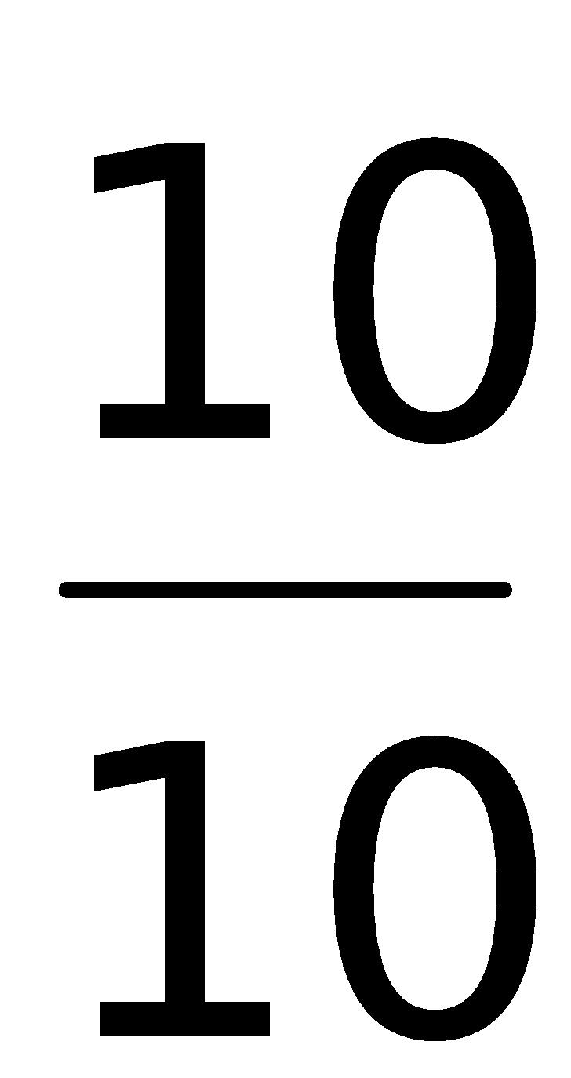.  So 0.6 is the same as 6 tenths thus the importance of calling it that way instead of zero point 6. So 6 tenths plus how many more tenths make 10 tenths. This makes it obvious the answer must be 4 tenths or 0.4.
34A. 0.7 = 0.2 + _____ | 5
34B. Partners to 2  2 – 0.4 | 5
34C. Finding the difference between a whole number and a number with tenths.  6 – 0.6 | 5
35. Looking at the difference between multiples of tenths to any number less than 2 that is also a multiple of tenths  1.5 – 0.6 | 4N11  5N11 | 0.4 + 0.5 = 0.9 or 4 tenths plus 5 tenths = 9 tenths.  0.6  1  1.5  0.4  0.5
36. Partners to any whole number with tenths.  6 – 2.5 | 4N11  5N11 | 2.5  3  6  0.5  3
37. Looking at the difference betwen any multiple of tenths and any other multiple of tenths that is greater.  Ex: 12.6 -7.9 | 4N11  5N11 | 4.6 + 0.1= 4.7  7.9  8  12.6  0.1  4.6
38. Partners to 1 with hundredths.  0.43 +_____=1 | 4N11  5N11 | Again here it is important to think about 0.43 as 43 hundredths as 1 is 100 hundredths or 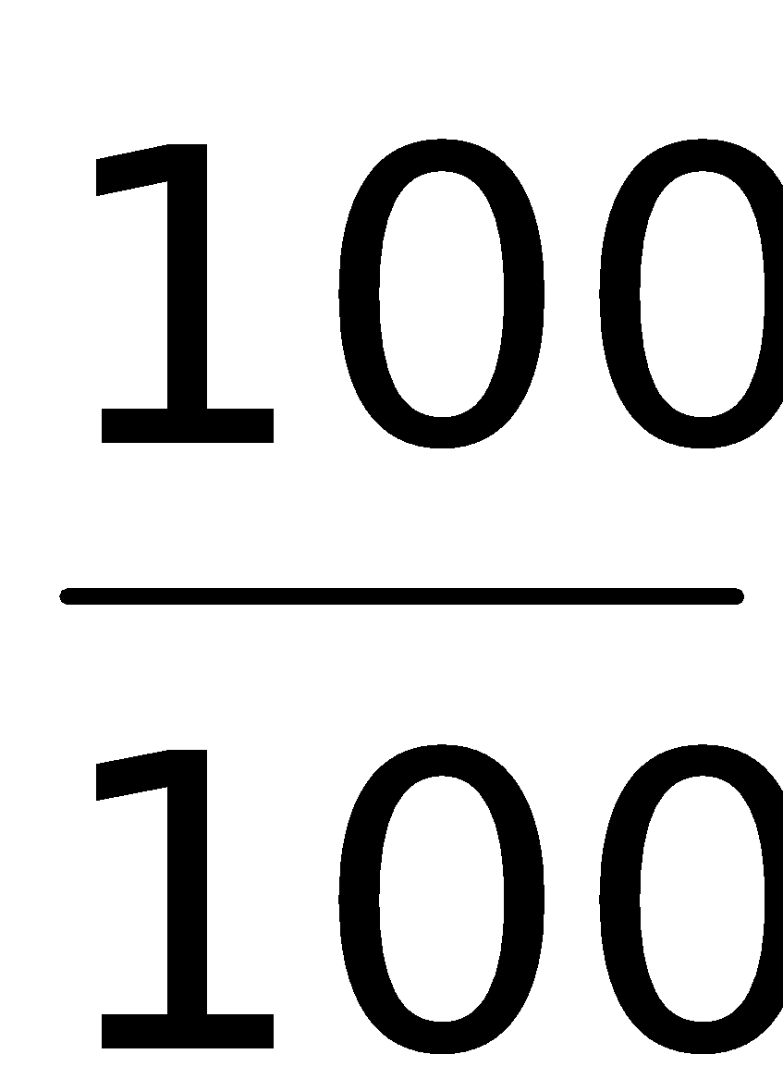. Therefore here we have 43 hundredths, how many more to make 100 hundredths. Clearly the knowledge of partners to 100 is important here and the answer is 57 hundredths or 0.57.
38A. Looking at the difference between a number with hundredths and a 1-digit number
3 – 0.75
38B. Looking at the difference between a number with ones, tenths and hundredths and a whole number
12 – 6.65
39. Looking at the difference between any multiple of hundredths less than 2 and any number that is a multiple of tenths that is more.  Ex: 1.5 – 0.53 | 4N11  5N11 | What makes this problem particularly difficult for children is their lack of understanding of place value. Therefore it is incredibly important to consistently use appropriate place value language when manipulating decimals. Here we have 47 hundredths that is being added to 5 tenths. Obviously, we need to start with the larger numbers, here the tenths so we have 5 tenths plus 4 tenths and that is 9 tenths and there is 7 hundredths left which makes 0.97. Student will want to add 47 plus 5 which is 52 and write it as 0.52 every time. Therefore prior to subtracting decimals, addition of decimals must be mastered.  0.53  1  1.5  0.47  0.5
40. Partners to any number with hundredths  1.45 +______=3.05  1.45 +______ = 3.5 | 4N11  5N11
41. Partner to 1 with thousandths.  0.453 + _____ = 1 | 6
Different types of questions that are all related to Subtraction…

Sequencing of the backward type.

EX : ___,___,___, 41, 42, 43
___,___,___, 110, 130, 150

Compare and order/Equality/Place Value

Which shows more, how many more?

Picture of 5 apples and picture with 3 dogs

2 tens or 23

45 hundreds or 4000

5 tenths or 0,05

Reprensenting

Showing different amounts of money, coins or bills

Writing numbers in numeral form or writing the number that is said

Reasoning

At least a 2-part problems related to subtraction (a loss, a comparison, I have, I want types of questions)

